**Please Create Another 5 Object-Oriented Examples and Give All Their Properties and Instances?**

**SUBMISSION**

1. Use graphics to show the examples.
2. Use Word Documents and attached the file to your GitHub
3. Submit before 24 Mac (Wednesday) at 8.00 am.

1. Class : Cat

Instances : MyCat, TanCat

|  |  |
| --- | --- |
| Class | Cat |
| States | * Colour : String * weight : double * name : String * age : int * hasShots : String |
| Behaviours | * changeName * Update shots * Update age * Update weight |

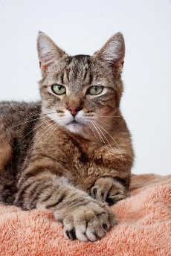 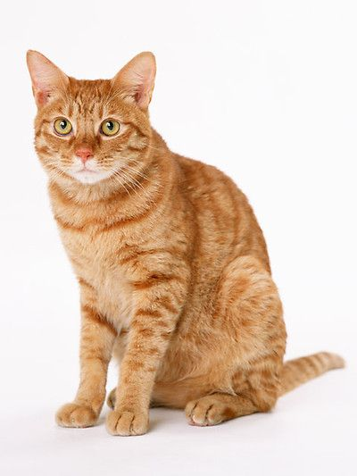

|  |
| --- |
| MyCat |
| Colour : Orange  weight : 2.50kg  name : Cola  age : 1 years old  hasShots : has |

|  |
| --- |
| TanCat |
| Colour : Chocolate  weight : 3.00kg  name : Lina  age : 2 years old  hasShots : has |

2. Class : Smartphones

Instances : MySmartphone , AbuSmartphones

|  |  |
| --- | --- |
| Class | Smartphones |
| States | * Brand : String * Model : String * Colour : String * weight : double * dimensions : double * onOff : Boolean |
| Behaviours | * powerOff * poweOn * ChangeVolume * MuteVolume |

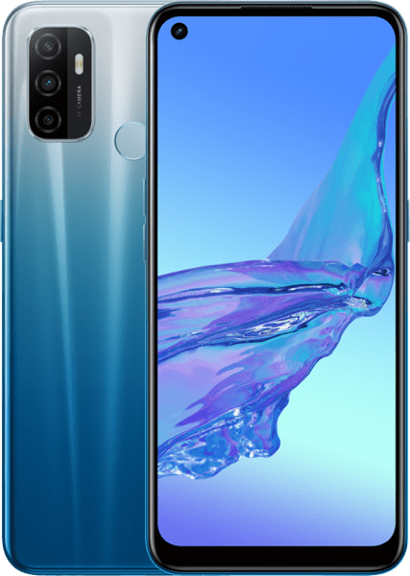 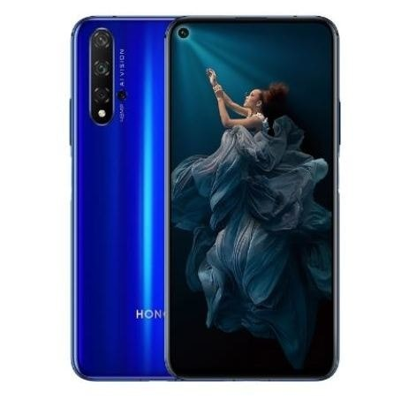

|  |
| --- |
| MySmartphones |
| Brand : HONOR 20  Model : YAL-L21  Colour : Midnight Black, Sapphire Blue, Icelandic white, Phantom Blue  weight : 174 g (6.14 oz)  dimensions : 154.3 x 74 x 7.9 mm (6.07 x 2.91 x 0.31 in) |

|  |
| --- |
| AbuSmartphones |
| Brand : OPPO A53  Model : CPH2127  Colour : Fairy White, Electric Black, Fancy Blue  weight : 186 g (6.56 oz)  dimensions : 163.9 x 75.1 x 8.4 mm (6.45 x 2.96 x 0.33 in) |

3. Class : Television

Instances : MyTelevision , AbuTelevision

|  |  |
| --- | --- |
| Class | Television |
| States | * Brand : String * Size : double * resolution : double * onOff : Boolean * channelNum : int * volumeLevel : int |
| Behaviours | * powerOff * poweOn * ChangeVolume * MuteVolume * ChangeChannel |

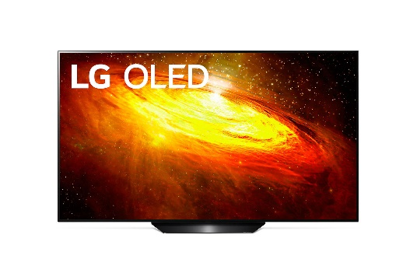 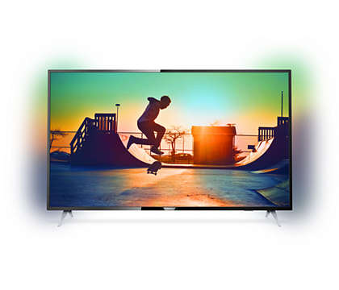

|  |
| --- |
| MyTelevision |
| Brand : PHILIPS Ultra Slim Smart LED TV Size : 55 inch  Resolution : 4K |

|  |
| --- |
| AbuTelevision |
| Brand : LG BX Smart OLED TV Size : 65 inch  Resolution : 4K |

4. Class : Car

Instances : MyCar, AbuCar

|  |  |
| --- | --- |
| Class | Car |
| States | * Colour : String * Layout : String * bodyStyle : String * brand : String * Manufacture : String * Max Speed : double |
| Behaviours | * Acceleration/Deceleration * Steer speed * Starter * Max Speed |

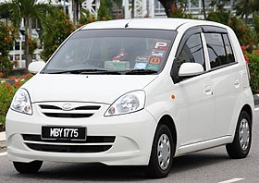 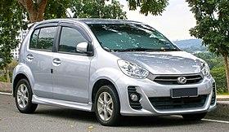

|  |
| --- |
| AbuCar |
| Colour : Silver  Layout : [Front-engine, front-wheel-drive](https://en.wikipedia.org/wiki/Front-engine,_front-wheel-drive_layout)  bodyStyle : 5-door [hatchback](https://en.wikipedia.org/wiki/Hatchback)  brand : Myvi  Manufacturer : Perodua  Max Speed :  220 km/h (136.70 mph) |

|  |
| --- |
| MyCar |
| Colour : White  Layout : [FF layout](https://en.wikipedia.org/wiki/FF_layout)  bodyStyle : 5-door [hatchback](https://en.wikipedia.org/wiki/Hatchback)  brand : Viva  Manufacturer : Perodua  Max Speed :  around 160 km/h (99 mph) |

5. Class : Bird

Instances : MyBird, AbuBird

|  |  |
| --- | --- |
| Class | Bird |
| States | * Colour : String * weight : double * species name : String * name : String * Size : String |
| Behaviours | * changeName * Update shots * Update size * Update weight |

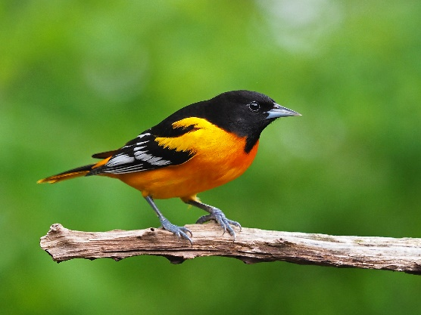 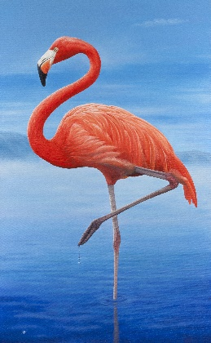

|  |
| --- |
| MyBird |
| Colour : pink, black, white and grey  Weight : 7.7 pounds (3.5 kg)  Species Name : Flamingo  Name : Pinky  Size : Big Size |

|  |
| --- |
| AbuBird |
| Colour : yellow, black, white and grey  Weight : 33.8 g (1.19 oz)  Species Name : Baltimore oriole  Name : Tweety  Size : Medium Size |